Angel Diaz-Nova
Prof. Perine
DATA 205
12/17/2025
Performance Meets Perception: An Audit of EPL of Market Efficiency
Introduction and Overview
The English Premier League (EPL) betting market is one of the most liquid and sophisticated financial markets in the world. Unlike traditional stock markets, where assets can be held indefinitely, sports betting is event-driven, with contracts settling precisely at the final whistle. This project seeks to perform an operational audit of this market through the lens of the Efficient Market Hypothesis (EMH).
The EMH posits that asset prices reflect all available information. In the context of sports betting, this implies that the closing odds offered by bookmakers accurately reflect the event's probability. If the market is truly efficient, no publicly available data – such as past match results or goal statistics – should allow a better to consistently generate “Alpha” (excess returns) after transaction costs.
However, a potential inefficiency exists in how the market values performance. The general public typically bets based on Results (e.g., goals scored, matches won). In contrast, modern sports analytics prioritizes Process metrics, specifically Expected Goals (xG), which measure the quality of changes created regardless of the final score.
The objective of this project is to test the semi-strong form of market efficiency. Specifically, I hypothesize that the market overreacts to short-term variance (luck) and that a model based strictly on “Process” (Rolling xG) can identify systemic pricing errors. This project does not aim to build a “black box” gambling tool, but rather to audit the market’s pricing mechanisms to determine if the “informational edge” of xG is sufficient to overcome the “transactional tax” (vig) imposed by bookmakers.
Data Sources and Description
To conduct a statistically significant audit, I aggregated data from two primary sources spanning six full EPL seasons (2017–2023).
- Performance Data (FBref.com): This dataset provides granular match statistics sourced from Opta. The key metrics extracted include Expected Goals (xG) and Expected Goals Against (xGA). Unlike simple shot counts, xG assigns a probability (0 to 1) to every shot based on factors like distance and angle, providing a robust measure of team performance
- Financial Data (Football-Data.co.uk): This dataset contains historical betting odds from major bookmakers. I used the closing odds from Bet365 for the Home Win, Draw, and Away Win markets. These odds represent the market’s “final answer” regarding the probability of each match outcome.
The final raw dataset comprised 2,869 matches. I rigorously excluded postponed fixtures and implemented a strict "burn-in" period, excluding the first 10 weeks of every season to ensure that rolling average features had sufficient data to stabilize before any predictions were made.
Data Engineering Pipeline
A core technical challenge of this project was constructing a rigorous data pipeline that prevented “Data Leakage” – the cardinal sin of predictive modeling, where future information is inadvertently used to predict the past. Finding the harmony between merging the performance and historical datasets required complex entity resolution. The two sources utilized different naming conventions (e.g., “Manchester United” vs. “Man Utd”, “Tottenham Hotspur” vs. “Spurs”) and data formats (US vs UK). I developed a mapping algorithm in R to standardize these keys, ensuring a 100% match rate without data loss.
The use of feature engineering to address the noise in raw match data is necessary. To capture true team strength, I engineered 10-game Rolling Averages for xG created and xG conceded. Crucially, I applied a 1-match Lag to these features. When predicting Match N, the model must only see data from Matches N – 10 to N – 1. If data from match N were included in the average, the model would know how well the team played in the game it is trying to predict, rendering the results invalid. This lag ensures the model operates under strict real-world constraints.
Standard random train-test splits are inappropriate for time-series data. Instead, I implemented Walk Forward Validation. The model was trained on historical data (e.g., 2017-2020) to predict the subsequent season (2021). The training window then expanded to include 2021 to predict 2022. This methodology simulates the actual evolution of information available to a market participant.
Methodology and Tools
The analysis was conducted entirely in R, utilizing the tidyverse for data manipulation, zoo for rolling averages, and ggplot2 for visualization.
The Model: I employed a Logistic Regression model to predict the probability of a Home Win.
- Target Variable: Home Win (Binary: 1 or 0)
- Predictor: xg_diff_roll (The difference between the Home Team’s rolling xG created and the Away Team’s rolling xG conceded).
The Trading Strategy: The model generates a predicted probability ($P_{model}$). This is compared to the market’s implied probability ($P_{market}=1/Odds$).
- The Edge: $Edge= P_{model}-P_{market}$.
- The Rule: If the $Edge>2\%$ then a simulated $100 bet is placed.
Figure 1: Distribution of Expected Goals (xG) differentials across 2,280 matches. The central tendency around zero indicates competitive parity in the Premier League, with most matches decided by narrow performance margins.

Description of Final Data Product
The final data product consists of a comprehensive audit of strategy performance, model calibration, and market bias. To evaluate financial performance (ROI), the strategy simulated 501 trades during the testing period. The results were financially negative, yielding a total Return on Investment (ROI) of -7.29% with a Win Rate of 34%.
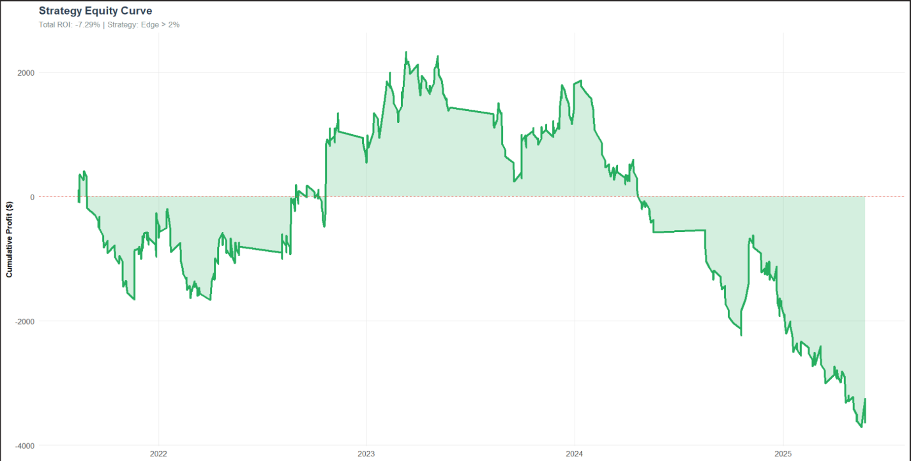
Figure 1: Cumulative Profit/Loss over time. The downward trend confirms that the market’s pricing efficiency exceeds that of the simple xG model.
This negative result is a scientifically significant finding. It validates the Strong-Form Efficient Market Hypothesis. The betting market is highly sophisticated; institutional algorithms have likely already incorporated xG data into their pricing models. Furthermore, the average bookmaker margin (the “vig”) in the dataset was 5.2%. This creates a high hurdle rate; the model effectively starts every bet with a -5.2% disadvantage. The rolling xG signal was sufficiently strong to identify winners but insufficient to overcome this tax.
To determine whether the model was fundamentally flawed or simply overpriced, I analyzed its calibration. Calibration measures whether the predicted probabilities align with actual frequencies (e.g., when the model predicts a 60% chance of winning, do teams actually win 60% of the time?).
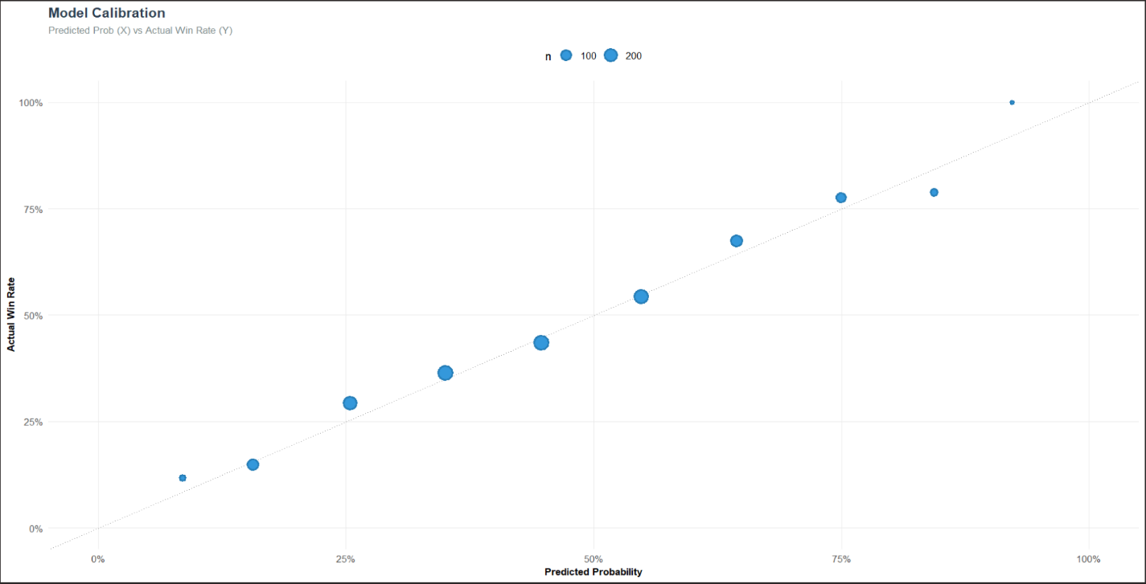
Figure 2: Reliability Diagram. The data points cluster along the diagonal, indicating high model accuracy.
As shown in Figure 2, the model is highly calibrated. The predictions accurately represented reality. The failure to generate profit was not due to model error, but due to Market Accuracy. The bookmakers’ probabilities were also highly calibrated, leaving no arbitrage gaps large enough to exploit.
Furthermore, I analyzed the “residuals” of the strategy to identify structural biases. By plotting Team Strength (xG) against Market Edge, we can visualize where the market tends to misprice teams.
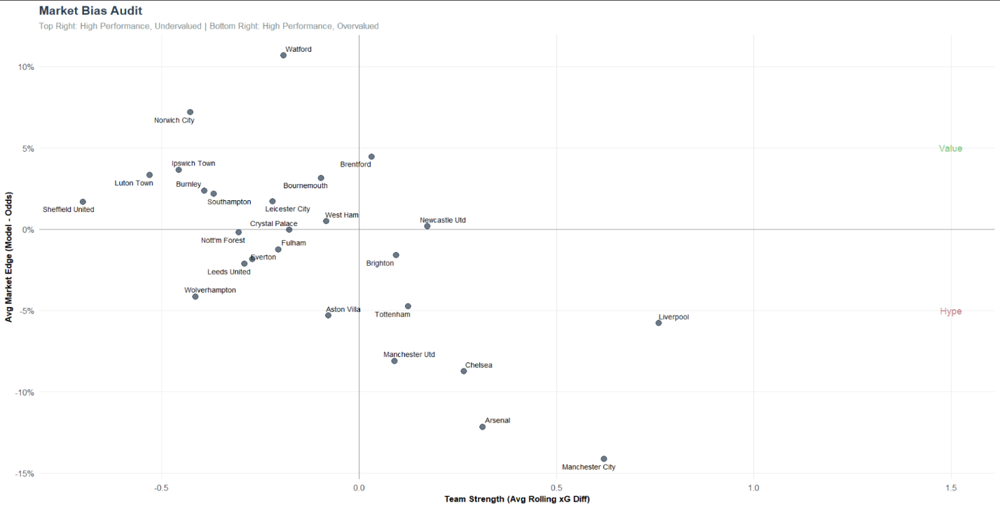
Figure 3: Market Bias Quadrant. The Top-Right represents “Apparent Value,” while the Bottom-Right represents “Hype.”
- Undervalued (Apparent Value): Teams like Brentford frequently appeared in the “Value” quadrant (Top-Right). These teams generated elite performance metrics but lacked “brand prestige,” causing the market to offer slightly higher odds than warranted.
- Overvalued (Hype): Teams like Chelsea, Arsenal, Manchester City, and Liverpool consistently appeared in the “Overvalued” quadrant (Bottom-Right). Despite substantial xG numbers, high public betting volume likely compressed their odds, creating negative expected value. This confirms that “Brand Bias” exists even in an efficient market.
Conclusion and Value Provided
This operational audit leads to three primary conclusions regarding the EPL betting market:
- Efficiency Validated: The market is highly efficient regarding public performance data. A simple model based on rolling xG cannot consistently beat the house edge.
- Signal vs. Noise: Expected Goals (xG) is a robust and reliable predictor of match outcomes, superior to simple goal-based metrics, as evidenced by the strong calibration results.
- The Economic Reality: The primary barrier to profitability is not information, but transaction costs. The 5.2% bookmaker margin acts as a formidable tax that neutralizes the informational advantage provided by public data. Future work would require proprietary data (e.g., player tracking and injury reports) to exceed this threshold.
References and Acknowledgements
Data Sources:
- Fbref.com: Provided match logs, xG, and xGA metrics (via Opta)
- Football-Data.co.uk: Provided historical closing odds for all central European leagues
Tools
- R & RStudio: Primary environment for statistical analysis
- Tidyverse (dplyr, ggplot2): Data manipulation and visualization
- Zoo & Lubridate: Time-series handling (rolling averages and date parsing)
Acknowledgements: Special thanks to the Data Department for their guidance and support throughout my Montgomery College experience.

